Disinfection guidance during outbreaks of viral infections such as Norovirus, Flu and Coronavirus: Product advice

The concentration needed to kill Norovirus, Flu or Coronavirus should be 1000 parts per million (ppm) or 0.1% available chlorine. However the dilution rates and contact times for hypochlorite solutions will vary with each product; even with domestic bottles of bleach. If you are struggling to work this out, the following information below provides dilution rates and contact times for 2 commonly used products:

Milton

- Milton fluid (containing 2% hypochlorite) should be diluted to 1 in 20 (divide the volume of water by 20 e.g. for 1 litre (1000ml) add 50 ml of Milton) to wipe over pre-cleaned surfaces and leave for 4 minutes.

- Milton tablets - add 1 Milton tablet to 500ml water to create a 1000ppm dilution. This will have a 4 minute contact time. You can also refer to a YouTube video about the product and how to correctly dilute it.
http://www.milton-tm.com/en/consumer/products/sterilising-tablets

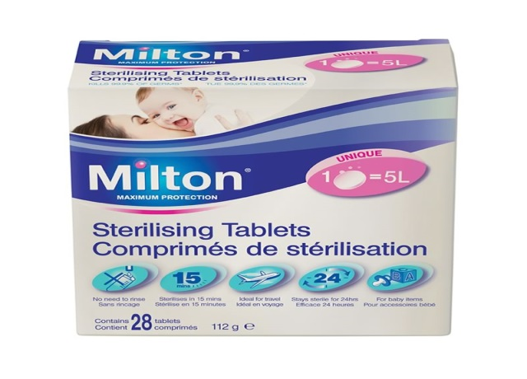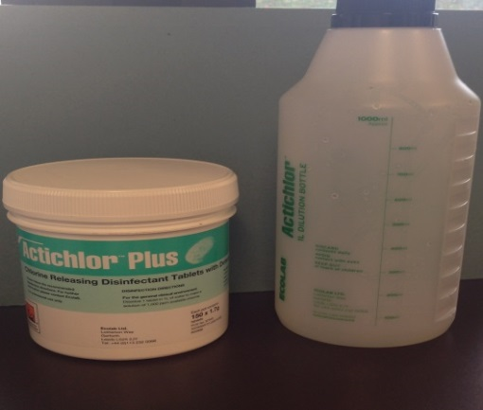

Actichlor Tablets

- An example of an effective tablet product that is effective against Norovirus, Influenza or Coronavirus is Ecolab Actichlor Tablets (follow the instructions for use to make up a 1,000ppm available chlorine).

For Ecolab Actichlor tablets, the product needs to be in contact with surface for a minimum of 5 minutes. You can also refer to a YouTube video about the product and how to correctly dilute it.
https://www.youtube.com/watch?v=qstlXdV2Wck.

Tel: 0300 123 66 96
Email: communicabledisease@cardiff.gov.uk

