
What will I need to do?

To achieve an award your business will be assessed against certain criteria that are based on principles of a healthy balanced diet, such as keeping fat, sugar and salt to a minimum, making fruit and vegetables widely available and basing main meals on starchy carbohydrates. You will also be assessed on having appropriate marketing and promotion of the healthier options.

How do I get involved?

If you are interested in achieving a Healthy Options Award, and are broadly compliant with food hygiene legislation i.e. score a rating of 3, 4 or 5 under the Food Hygiene Rating Scheme.

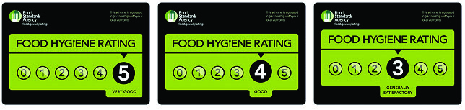

Contact:

Allyson Jones
Commercial Services
Shared Regulatory Services

Tel: 07794047791
E-mail: Alljones@cardiff.gov.uk

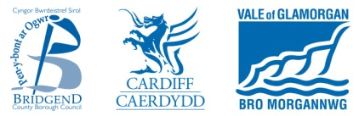

What is it?

Eating out increasingly plays an important part in our lives – over one third of all money spent on food and drink in Wales is eaten outside the home, with people increasingly looking for healthy options.

The Healthy Options Award has been developed to reward caterers who make it easier for their customers to make healthy choices when eating out. It has three levels - Bronze, Silver and Gold, and is symbolised by the apple logo with heart shaped pips.

What are the aims?

The award aims to encourage food businesses to provide healthier options to customers, through the use of healthier catering practices, increasing fruit, vegetables and starchy carbohydrates, as well as decreasing fat, especially saturated fat, sugar and salt. It also recognises provision of healthy options for children, rewards staff training, promotion and marketing of healthier options.

Why is it important?

You’ve only got to look in the press or on TV to see the growing concerns about diet related diseases. Over half of us in Wales are now overweight or obese. Diet plays a major role in heart disease, some cancers and over one in four deaths in Wales are linked to what we eat. Caterers can therefore make a big difference to our nation’s health.

Who can apply?

The award is open to all types of catering premises that cater for the general public.

The premises must be broadly compliant with food hygiene legislation i.e. score a rating of 3, 4 or 5 under the Food Hygiene Rating Scheme.

Who runs the award?


The award is assessed and managed by Shared Regulatory Services Commercial Services Team.

What’s in it for me?

The Healthy Options Award is good for:
- You
- Your Business
- Your Customers

You could make a tremendous contribution to improving your customers’ diet and health by providing healthier food choices.

You’ll have public recognition for achieving the award and could enhance your image as a responsible business that puts its customers first. It could give you a competitive edge and increase customer satisfaction. As the demand for healthier choices continues to grow - many food manufacturers and retailers who have introduced healthier options are seeing a growth in sales.

