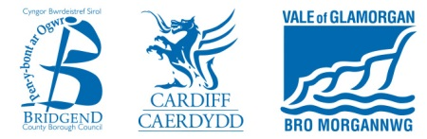
Application Pack
for the
Approval of a Food Business Establishment
Under EC Regulation 853/2004
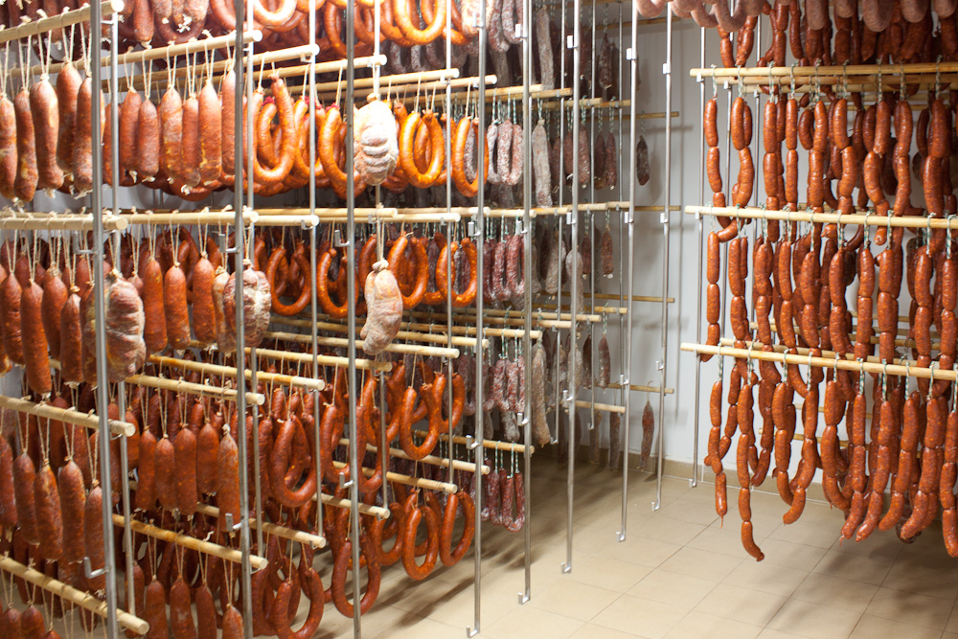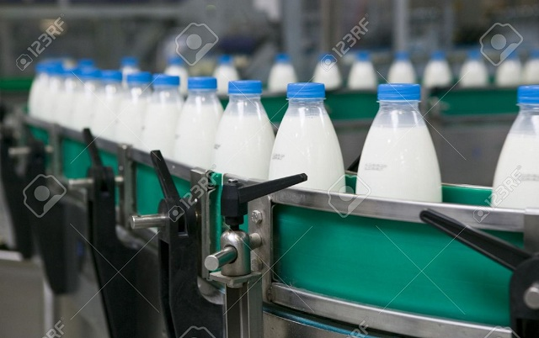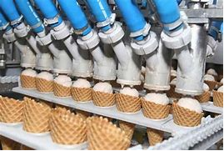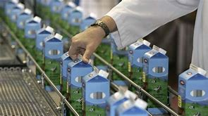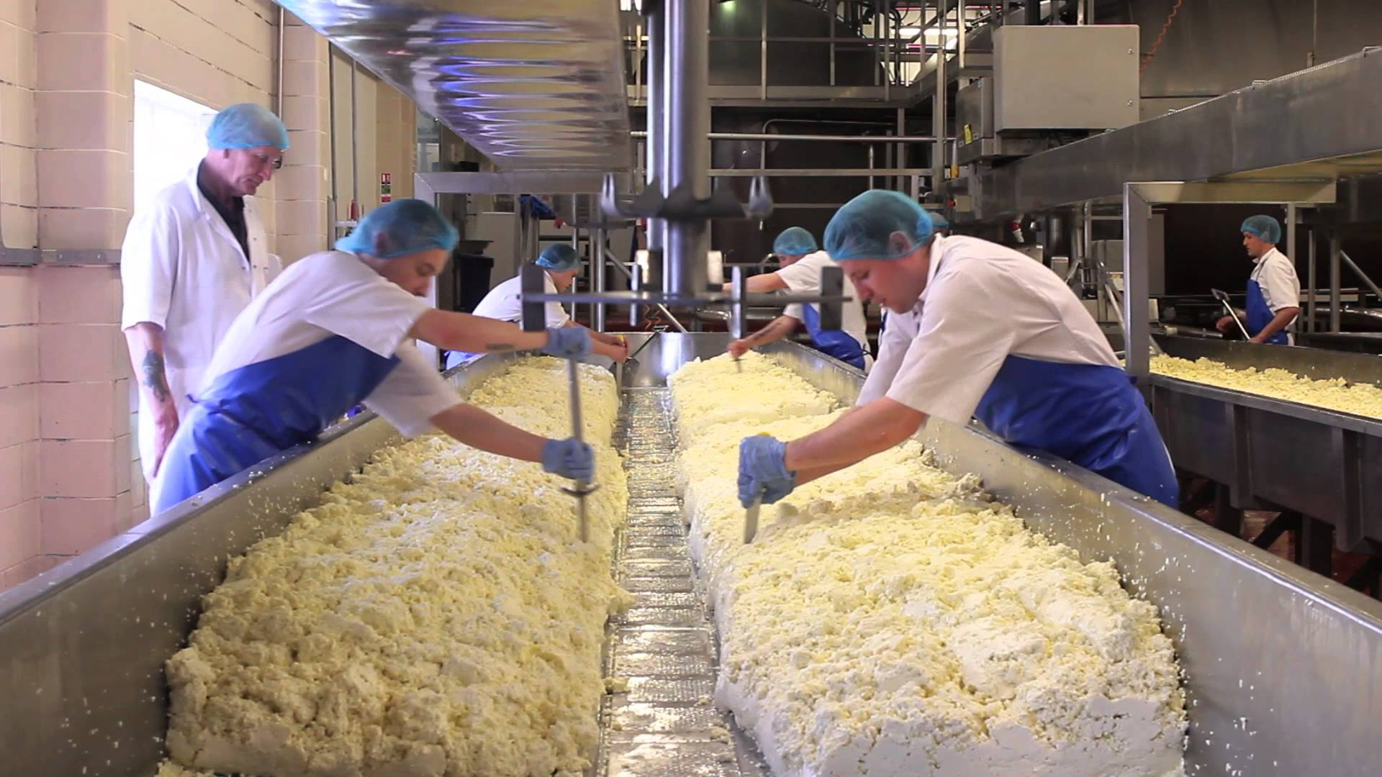

Contents
Page 2 | Contents
Page 3 | Application Process Explanation
Page 4-7 | Link to downloadable Application Form, Information on Approval under EC Regulation 853/2004 and questions and answers
Page 8-10 | Guidance Notes on Completing Application Process
Page 11 | Managing Food Safety/HACCP
Page 12-14 | Selecting a HACCP Consultant
Page 15-19 | Selecting a Microbiology Laboratory
Page 20-30 | Appendix 1 – Approval Application letter and form

EXPLAINING THE APPROVAL APPLICATION PROCESS
You have recently expressed an interest in opening a Food Business Establishment which requires approval under Regulations (EC) 852/2004 and 853/2004,
Or
It has recently been determined that your Food Business Establishment requires approval under Regulations (EC) 852/2004 and 853/2004.
This starter pack is intended to give you information and guidance to assist you in your application and understanding of the approval requirements and process. The approvals process can be quite lengthy and time consuming, so you will need to begin your application as soon as possible.
The following documents are contained within this starter pack to assist you both in making your application and to understand the requirements that you will have to reach for approval to be granted.
- Information on the Approval process and how to apply
- Guidance notes for the completion of the application form
- An application form – Application for Approval
- Synopsis of requirements under the Food Hygiene Regulations
- Guidance issued by the Food Standards Agency
- Guidance on how to choose a Consultant
- Guidance on how to choose a laboratory to carry out sampling.

When applying, please sign and date the application form, complete all relevant sections and forward all of the required supplementary information, as any errors or omissions may delay the processing of your application or could result in refusal of your application.
Once we have received your application, we will process it and arrange for an officer to contact you to discuss your application and arrange a pre-approval visit to your premises. We may be processing other applications and undertaking other food safety work, therefore may not be able to give an immediate reply.
You will find throughout the pack, multiple links to the legislation and further guidance.
If you require further information or advice on the application or approval process, please contact us at businessadvice-srswales@valeofglamorgan.gov.uk
LINK TO DOWNLOADABLE APPLICATION FORM, INFORMATION ON APPROVAL UNDER EC REGULATION 853/2004 AND QUESTIONS AND ANSWERS
Information on Approval under EC Regulation 853/2004
Certain food businesses will require approval from the local authority before they start trading. Your local authority council details can be found at https://www.gov.uk/find-local-council
This is separate from the requirements for food registration that applies to all food businesses.
Further details on Approved Premises can be found at the following link https://www.gov.uk/food-premises-approval-wales
To make an application, follow the link to a downloadable application form on our website https://www.srs.wales/en/Environmental-Health/Food-Hygiene-Standards/Approved-Premises.aspx or see the details at the bottom of the pack.
In addition to the question-and-answer series below, you may follow the link to the Food Standards Agency Code of Practice website. The Approval process is described in detail from Page 4 in the Food Law Practice Guidance. Please ensure that you look at the Wales Guidance only for establishments in Wales.
Food Law Code of practice
https://www.food.gov.uk/about-us/food-and-feed-codes-of-practice
Q. What type of businesses requires approval?
The requirement for approval depends on the type of foods handled or processed and the types of businesses supplied. Food businesses that process or handle certain foods of animal origin and supply these foods to other food businesses or establishments will generally require to be approved.
GB
AA123

Premises that are approved will carry an Identification Mark as above.
Establishments that process foods of animal origin and only supply them directly to the final consumer (i.e. the public) are exempt from approval. Establishments that process foods of animal origin and supply both the public and other local food business establishments may also be exempt from approval. Potential applicants for such establishments should contact the Food Safety Industry Team, email businessadvice-srswales@valeofglamorgan.gov.uk for further advice and guidance prior to making an application for approval.
Establishments that only produce or handle foods that contain both processed foods of animal origin and products of plant origin may be exempt from approval. For example, if an establishment produces sandwiches from already cooked meats (processed food of animal origin), salad and bread then approval will not be required. If, however, the establishment cooks raw meat which it uses for producing sandwiches, approval is required.
https://www.food.gov.uk/business-guidance/approved-food-establishments
The Guidance above will give an indication as to whether you require approval and who (Local Authority or Food Standards Agency) will be the enforcement authority.
Establishments that are proposing to be involved in the slaughter, dressing or cutting of fresh meat will need to be approved by the Food Standards Agency who should be contacted directly. A copy of the Food Standards Agency's application form and contact details can be obtained at the following link:
https://www.food.gov.uk/business-guidance/applying-for-approval-of-a-meat-establishment
Q. What structural requirements do approved premises have to comply with?
Establishments that require approval must comply with the general hygiene requirements (given in EC Regulation 852/2004) and some specific hygiene requirements which vary depending on the types of products you make (given in EC Regulation 853/2004). Shelf-life testing and sampling may need to be undertaken. (Regulation EC 2073/2005) Establishments must also put in place a documented food safety management procedures based on the HACCP principles. Additional information on structural requirements can be found https://www.srs.wales/Documents/Food/SRS-FoodBusiness-FEB-2020-E.pdf
Q. What are foods of animal origin?
The foods of animal origin that are subject to approval are:
• Fresh meat, minced meat, meat preparations, (e.g. raw sausages, bacon, burgers, kebabs), mechanically separated meat, meat products,(e.g. cooked pies, cooked meats and ready meals), live bivalve molluscs, fishery products, milk and dairy products, eggs and egg products, frogs legs and snails, rendered animal fats and greaves, treated stomachs, bladders and intestines, gelatine, collagen.
- Please note that if you are handling or growing sprouts and sprouting seeds to supply to other businesses, you will also need approval for this activity.
Q. Who should apply?
All food business establishments that are subject to approval under EC Regulation 853/2004 must apply before trading. The application should be made by the food business operator.
The Food Safety Industry Team should be contacted by food businesses that may be subject to approval to discuss the proposed operation and for advice on whether approval will be required.

Q. When should I Apply?
Food businesses that are subject to approval under EC Regulation 853/2004 must have approval from the food authority before they start trading. A food business will be committing an offence if it places on the market foods that are subject to the relevant requirements of EC Regulation 853/2004 without having prior approval and would be liable to prosecution. The local authority must process your application before it can be granted.
Q. How Do I Apply?
The application form for approval is enclosed within this Starter Pack (Appendix 1); or alternatively visit our website https://www.srs.wales/en/Environmental-Health/Food-Hygiene-Standards/Approved-Premises.aspx.There is no charge for Approval and generally, it is a one-off procedure.
The application form must be accompanied by supporting food safety documentation that is needed to determine the application. Details of the information required are given on page 3 of the application form. Without all of this information, the application will not be deemed as duly made, and therefore cannot be processed.
For proposed businesses not yet trading, applications for approval must not be submitted unless the business concerned as a minimum can meet the infrastructure requirements of EC Regulations 852/2004 as the application is likely to be refused. This means that the premises, design, layout, equipment and systems must enable the establishment to produce safe food. A documented food safety management procedure based on HACCP principles must also be available.
In order to gain full Approval status, the business will need to meet the full requirements of Regulations EC 178/2002, 852/2004. 853/2004 and 2073/2005. There may also be other legal requirements that apply to the business.
Q. What happens to my application when it is submitted?
An applicant will be contacted by an officer from the Food Safety Industry Team to discuss the proposed operation and confirm if approval is required. Following receipt of all relevant documentation, an on-site inspection will be carried out to verify that the premises, systems, procedures and documentation meet all of the legal requirements for the business type. Once the inspection has been carried out, the approval status of the establishment will be determined.
• If the establishment fails to meet the infrastructure and equipment requirements, approval will be refused.
• If all of the legal requirements are met full approval will be granted.
• Conditional approval may be granted if the establishment does not fully comply with all of the relevant requirements but meets all of the infrastructure and equipment requirements.
If conditional approval is granted, a further inspection will be carried out within 3 months to ensure that all of the relevant legal requirements have been met. If these have not been met, providing satisfactory progress is being made to meeting full approval conditions, then conditional approval can be extended but this is restricted to a maximum of 6 months from the date when conditional approval was granted. If at the end of the 6 months, the establishment still does not meet all of the relevant legal requirements then approval will be refused.

Q. Is there a register of approved premises from which my customers can verify my approval?
A national database of approved food business establishments is held by the Food Standards Agency and can be accessed at
https://www.food.gov.uk/business-guidance/approved-food-establishments
Q. What if my application is refused and approval is not granted?
Applicants will be notified in writing of the reasons for refusal and of the actions that will be necessary to meet the relevant requirements of food law for approval.
Once approval has been refused activities that require approval may not be undertaken by the business without full or conditional approval. Food businesses that start or continue to trade without approval will be committing an offence and are liable to prosecution.
Applicants have a right of appeal against a decision to refuse approval. Appeals must be made to the local Magistrates Court and must be made within 1 month of the date of the written refusal.

GUIDANCE NOTES ON COMPLETING THE APPLICATION PROCESS FOR APPROVAL
These guidance notes aim to assist you in completing your application form fully and correctly.
If you require any additional advice please contact businessadvice-srswales@valeofglamorgan.gov.uk
- Local authority details
Please ensure that all the LA details completed correctly and fully. The Shared Regulatory Services cover three Local Authority Areas, so please choose the one in which the premises is situated.
2. Premises for which approval is sought
Trading name: the name that the owner conducts their business under (if applicable). This cannot be the name of a different registered company.
Address: Complete address including postcode. Make sure the full telephone number is included. Please also provide a full email address.
3. FBO details and business structure
It is vital that the details in this section are correct. If you have any doubt as to the structure of your business seek legal advice or contact Companies House.
All FBOs fall into one of the following categories:
· sole trader
· partnership
· incorporated and registered company
· other business types such as cooperatives, registered charities and other specialised types of organisation. These will be treated on a case-by-case basis to identify the natural person or legal person required to be compliant with food law within the food business under their control.
Only complete section 3a if you have a company registered at Companies House. Make sure the company information is completed in full.
Details for the company directors should be listed in full. This does not include senior management. If necessary, please continue on a separate sheet and attach.
Only complete section 3b if you are trading as a partnership or sole trader. You should list the details accurately including telephone numbers, address and email. If necessary, please continue on a separate sheet and attach.
Note: An FBO is the natural or legal persons responsible for ensuring that the requirements of food law are met within the food business under their control.

4. Establishment managers and contacts
List all the relevant managers and staff who will hold a position of responsibility
For a limited company, a duly authorised representative (the individual delegated to speak or act on behalf of the FBO) must be entered.
For partnerships/sole traders a duly authorised representative of the FBO only needs entering if different to the individuals listed in Part 3b.
The competent authority dealing with the approval process may be required to contact the FBO should there be an emergency and for contingency planning purposes (for example, foot and mouth outbreak). This information is voluntary.
5. Activities for which approval is sought
Clearly mark a cross in the box, or boxes, the activities for which approval is sought. There may be more than one approvable activity, in which case mark X in the box for all that apply to this establishment
Indicate an estimated amount of the product (s) for which approval is sought that is processed in the establishment per week in kilograms. Ensure this figure is provided next to all activities selected.
Provide a description of what the activities include and any further information that supports the approval decisions. Provide as much detail as possible on the activities and products processed in the establishment. The more information recorded the smaller the margin for error throughout the approval process. Please expand the boxes accordingly to accommodate more text or continue onto an additional page and attach to this document.
Note: In accordance with Retained Regulation (EC) No. 853/2004, Annex I, point 7.1, meat products are defined as ‘processed products resulting from the processing of meat or from the further processing of such processed products, so that the cut surface shows that the product no longer has the characteristics of fresh meat’.
Note: In accordance with Retained Regulation (EC) No. 853/2004, Annex I, point 1.15, meat preparations are defined as ‘fresh meat, including meat that has been reduced to fragments, which has had foodstuffs, seasoning or additives added to it or which has undergone processes insufficient to modify the internal muscle fibre structure of the meat and thus to eliminate the characteristics of fresh meat’.
6. Products to be processed/activities to be conducted by the establishment
Clearly mark a cross in the box for each activity/process to be conducted in the establishment
Please make sure you list all applicable sales routes, even if some are used infrequently
7. Other activities at the same site
Clearly state yes or no for each activity. Please include any other approval codes if relevant.
Please note, in accordance with Retained Regulation (EC) No. 853/2004, Annex 1, point 1.17, a cutting plant means an establishment used for boning and/or cutting up meat. If the establishment is doing this but only for a product that will be minced or used for a meat preparation, then they are not deemed a cutting plant.
8. Information and documentation
Clearly mark a cross in the box for all additional documentation supplied
These additional documents will be essential for the approval of the establishment. Use this checklist to make sure that all documents are available at an approval visit. Failure to produce this additional information may result in a delay to the approval process.
9. Declaration
Make sure the name is completed in BLOCK LETTERS, dated. An electronic version emailed will also be acceptable with a scanned in signature.
Note: If you fail to complete all relevant parts of this form your application for approval will not be processed
Once you have checked the form and are satisfied that it is fully completed and you have the appropriate accompanying documentation to be submitted with it, you should send it to the Officer you are dealing with, or, if send to businessadvice-srswales@valeofglamorgan.gov.uk

Download the form our website: Approved Premises (srs.wales)

MANAGING FOOD SAFETY/HACCP

1. Producing food safely doesn’t happen by accident. You need to manage the process to protect your customers and your reputation and to comply with the law. The hygiene rules require you to have in place food safety management procedures based on the HACCP principles.

2.. The procedures you operate will need to demonstrate to your enforcement officer that;
• Hazards to food safety which might be present within your business are identified (“What can go wrong, when and where?”).
• Controls are in place to deal with these hazards. (“What can I do about it and where?”)
• Controls are carried out and checked. If something goes wrong everyone is clear what to do about it and then does it. (“What is acceptable?” “How can I check?” “What can I do about it?”)
• Procedures are kept up to date (“If I change my way of preparing food, do I need to change my food safety controls?”).
• Documents are kept which are necessary to show what the procedures are, (“What documents should I keep to show what my procedures are?”).
• Records necessary to show the procedures are working are kept (“What records should I keep to show my procedures are working and any problems have been put right”?)
The precise requirements can be found in Article 5 of Regulation (EC) No 852/2004.
In addition, procedures in slaughterhouses have to comply with Annex II, Section II of Regulation (EC) No 853/2004.

3. General FSA advice on food safety management can be found on the web site at
https://www.food.gov.uk/business-guidance/hazard-analysis-and-critical-control-point-haccp
as can further help for businesses on producing food safely.

GOOD PRACTICE GUIDES

4. The food hygiene regulations provide for the development of guides to good practice for hygiene and the application of HACCP principles. Food business operators may use these guides as a voluntary aid to compliance with their obligations under the food hygiene legislation. Enforcement officers must take account of these guides when assessing compliance with food law. Further information on good practice guides and their development can be found on the FSA website at https://www.food.gov.uk/business-guidance/industry-guides-to-good-food-hygiene

SELECTING A HACCP CONSULTANT
Depending on the nature of your food business, you may wish to hire a consultant to assist you with writing or reviewing your HACCP and the approval application.
The implementation of food safety management system based on HACCP principles in your food business is a legal requirement but, as a complete approach to the way you operate your food business, will also help you prevent other problems that may occur such as wastage.
As with any new procedure, you must fully understand it in order that you can implement and maintain the system. An outside consultant with expertise in implementing HACCP systems can be a valuable member of your team. The food business operator and the HACCP consultant should work closely together in a collaborative way to write down and implement the HACCP system.
Why hire a consultant?
A consultant brings expertise and experience to your project and assists you by:
- Providing technical support as you create and document your HACCP system.
- Providing training in HACCP at an introductory level so that you understand the reasons and rationale of the HACCP approach
- Providing feedback on your specific HACCP system and suggesting improvements
- Assisting with HACCP documentation and record keeping
- Assisting with HACCP training
- Assisting with HACCP review and auditing
What should you expect from a consultant?
- Technical knowledge of food production and processing and its associated hazards
- Clear understanding of HACCP
- Qualifications and experience in implementing HACCP
- Willingness to provide support and training, as required, to both management and staff members directly involved in the HACCP system.
- Willingness to work with plant personnel to ensure a well-designed system.
How do you find a select a consultant?
There are no directories of HACCP consultants although you will find a list of consultants in food safety on the Chartered Institute of Environmental Health Officers website link –
http://www.ehn-online.com/consultantsdirectory/consultants.aspx
There will also be details of food safety consultants on the internet and in yellow pages.
Trade associations may also be able to provide details of consultants
Whoever you approach, undertaking a rigorous selection process will ensure that you know exactly what the consultant is expected to deliver.
A potential consultant should be able to answer questions such as:
- What are your qualifications?
The expert must be able to demonstrate a high level of technical knowledge and skill relating to the food production and/or processing industry.
- What experience do you have in implementing HACCP systems?
This is your opportunity to explore the consultant’s background specific to HACCP implementation. Asking for examples of documentation from other projects gives you an idea of the quality of the supplier’s work.
- Can you provide references and samples of previous work from previous clients.
References allow you to assess the credibility of your potential consultant
Samples allow you to assess how user friendly their procedures and records are.
- Are you willing to spend time on site, identifying specific needs of my company?
An effective consultant will make the time to spend with you, listening to your concerns and explaining the best way to meet your needs. Consultants will need to have an in-depth understanding of your facility and operations to be able to provide sound advice on the development of a specific HACCP system.
- What will you provide by way of follow up support once the system is implemented?
The process of implementing your HACCP system may take time. Is the consultant prepared to offer ongoing support once the system is in place? Will training be part of the process?
What details should you and your consultant agree on in a contract?
Once you are satisfied that you and your consultant are able to work together towards meeting your companies needs, you should finalise specific details in a contract. Issues that also need to be addressed may be:
- How long will the project take? What is the breakdown of tasks and how long will it take to complete each one?
- What is the projected cost and what are your payment options?
- What material must remain confidential?
Working with a HACCP Consultant?
The process involves both of you and the HACCP consultant, working together towards successful implementation.
You might rely on the consultant’s suggestions and advice but your direct involvement in the implementation and management of the system is still essential.
You must ensure that you and your staff are fully familiar with the food safety management system before he/she is finished.
A carefully chosen consultant, who is willing to work closely with your facility and whose expertise match the needs of your company, can be a valuable tool in the implementation of an effective HACCP system.
Additionally, Zero2Five is a part of the Cardiff Metropolitan University and has been set up with wide remit which includes helping small businesses with product development. They also have access to a range of grant funding from the Welsh Government and other sources so they may be able to provide financial assistance in some circumstances. Zero2Five Food Technology Centre: https://www.cardiffmet.ac.uk/health/zero2five/Pages/default.aspx

SELECTING A MICROBIOLOGY TESTING LABORATORY
This leaflet has been produced to help you find a laboratory that can test your food produced. This may be to demonstrate the microbiological quality of your food and/or validate or verify the correct functioning of your food safety management system or to determine the shelf life of your products.
What do I need to consider?
Depending on why and what you are testing, you will need to select an appropriate microbiological laboratory.
Although many laboratories are accredited by UKAS (United Kingdom Accreditation Service), others may not be but may still be appropriate to use.
If you want to test the shelf life of your food or checking to demonstrate the quality of foodstuffs against the criteria set in law by Regulation (EC) 2073/2005, then you will need to select a laboratory which uses certain 'analytical reference methods'. These are:
- Listeria monocytogenes – EN/ ISO 11290-2'
- Salmonella. - 'EN/ISO 6579'
- Histamine. - 'HPLC'
- Sampling from processing areas and equipment - ISO standard 18593
In addition, you may wish to ask the laboratory whether they will compare the results with the standards set in the Public Health Laboratory Service 'Guidelines for the microbiological quality of some ready-to-eat foods'.
What do I need to ask about shelf life testing?
You will need to have documentation from the laboratory of the recommended shelf lives of each type of ready-to-eat foods being tested, based on the testing and studies undertaken. These tests need to include the physical and chemical qualities of your products such as the salt, water, pH, preservatives that you may use and your type of packaging. The laboratory must be able to do these tests for you and report back to you on it.
You should ensure that the shelf-life testing will be carried out at 8° C, even if your food labels recommend storing the food at 0-5 °C. This is because this is the temperature criteria set by law for most businesses to store foods which may cause food poisoning unless they are stored under temperature control.

Do I need to do water testing?
Yes, all approved premises will require water sampling to prove that they water supply, and their distribution system, provides safe water for cleaning of the equipment and/or as an ingredient in the foods.
As the definition of food includes water intentionally incorporated into food during its manufacture, preparation or treatment, food business operators have a responsibility for the quality of water used directly, e.g. as an ingredient in food production, or indirectly, e.g. in cleaning or processing during the manufacture of foods.
The quality of the water used by food business operators in food production must meet the basic standards governing the quality of drinking water, i.e. potable water, intended for human consumption as set out in The Water Supply (Water Quality) Regulations 2016.
What if my premise is approved?
If your premises are approved, when choosing a laboratory, you should make sure that the laboratory will provide you with documents stating the tests undertaken and an analysis of their results. This is so that you can demonstrate the microbiological criteria of the food based on the Regulations or on the PHLS guidelines.
This is also important if you undertake shelf life testing. You will need to have documentation from the laboratory of the recommended shelf lives of each type of ready-to-eat foods being tested, based on the testing and studies undertaken.
What about unsatisfactory test results?
Should any of your foodstuffs produce unsatisfactory test results, then you must agree with the laboratory how they will immediately inform you. This is because there may be a legal requirement to immediately recall the food from customers and also to inform the food authority.

Please note that sampling requires a standardised recipe for your food products to ensure consistency with any results obtained. Sampling is also not a one-off activity or expense – approval requires a sampling policy to be produced so that you can regularly monitor the implementation of your HACCP and general food hygiene at your business.

THESE LOCAL FOOD LABORATORIES WILL PROVIDE ADVICE AND WILL CARRY OUT TESTING:
You should note that in order to avoid any conflict of interest, none of the following laboratories or organisations can be recommended by the officer distributing this information.

Public Health Wales:
Llandough Hospital Site
Penlan Road
Llandough
Penarth
CF64 2XX
029 2071 6745 https://phw.nhs.wales/services-and-teams/reference-laboratories-and-specialist-services/food-water-and-environmental-fwe-services/
Celtic Food Labs:
Celtic Food Laboratories,
Rizla House,
Severn Road,
Treforest Industrial Estate,
Pontypridd,
CF37 5SP
Telephone: 01443 843847 http://celticfoodlab.com/

Association of Public Analysts:
Minton Treharne and Davies Ltd
Forest Farm Industrial Estate
Longwood Drive, Whitchurch
Cardiff
CF14 7HY
Tel 02920 540000 http://www.publicanalyst.com/about_us/the_laboratories/

One Scientific:
Unit 3
Avon Riverside Estate, Victoria Rd
Avonmouth, Bristol BS11 9DB
Telephone: 01179382410 https://onescientific.co.uk/

Also a list of laboratories that are accredited by UKAS for Food & Food Production testing can be viewed here: https://www.ukas.com/find-an-organisation/browse-by-category/?cat=1203
Each laboratory will have a different fee structure so you will need to discuss your requirements and make a commercial decision based on your business needs.

THESE FOOD RESEARCH ORGANISATIONS WILL PROVIDE ADVICE AND SOME WILL CARRY OUT TESTING:
Institute of Food Research.
Norwich Research park
Colney
Norwich
NR4 7UA
www.ifr.ac.uk
Tel: 01603 255000.

Campden and Chorleywood Food Research Association
Chipping Campden
Gloucestershire
GL55 6LD
Tel: 01386 842000
Email: info@campden.co.uk
www.campden.co.uk
Leatherhead Food International
Great Burgh
Yew Tree Bottom Road
Epsom
Surrey
KT18 5XT
Tel: 01372 376761
www.leatherheadfood.com

LISTS OF LABORATORIES
FSA link:
https://www.food.gov.uk/about-us/official-feed-and-food-control-laboratories#t
UKAS – has a list of laboratories they have accredited.
21-47 High Street
Feltham
Middx
TW13 4UN
Tel: 020 89178400
www.ukas.com

Other accredited laboratories may be sourced from looking on the internet or yellow pages by searching under food laboratory, food testing etc.

TRADE ASSOCIATIONS
Chilled Food Association
PO Box 6434
Kettering
NN15 5XT
Email: cfa@chilledfood.org
Tel: 01536 514365.

Application for Approval of a Food Business Establishment
Subject to Approval under: Regulation (EC) No. 853/2004

To be completed by the food business operator (FBO)
Print a copy of this form and fill it in with a black pen in BLOCK CAPITALS or complete it on screen. Complete Parts 1 to 9 inclusive in relation to the products of animal origin of which you are applying for the approval of your establishment, then sign and date Part 10.
You should notify the Local Authority in writing of any changes to the details of this form, including any changes in the operations carried out and products handled in the establishment.

PART 1 – Local Authority

Local Authority Name:  * Please delete as appropriate | Cardiff Council/  Bridgend County Borough Council/  Vale of Glamorgan Council
Local Authority Address:  * Please delete as appropriate | County Hall, Cardiff, CF10 4UW/  Civic Offices, Angel Street, Bridgend, CF314WB/  Civic Offices, Holton Road, Barry, CF63 4RU
Tel: | 0300 123 6696 | Email: | businessadvice-srswales@valeofglamorgan.gov.uk

PART 2 – Premises for which approval is sought

Trading Name:
(Name under which you conduct your business)
Full Premises
Address:

Telephone:

Email:

PART 3 – Individual details and business structure

Please indicate the type of business:

 | Company (now complete 3a)

 | Partnership (now complete 3b)

 | Sole Trader (now complete 3b)

 | Other type (provide details on a separate sheet and attach *

*Other business types will be treated on a case by case basis to identify the natural person or legal person required to be compliant with food law within the food business under their control

PART 3a - Company Details (as registered with Companies House or equivalent)

Full Company Name:
Registered Office Address (including postcode):

Company Registration Number:

Director(s) Name(s):

Email:

Telephone:

PART 3b - Complete only if Partnership/Sole Trader
(Provide full details for all Partners – if required continue on a separate sheet and attach)

Duly Authorised Representative:
Position:

Email:

Telephone:

Contact name two:
Position:

Email:

Telephone:

Contact name three:
Position:

Email:

Telephone:

PART 4 - Establishment managers and contacts

Manager – responsible for day-to-day operations of the establishment:

Name:

Email:

Telephone:

Technical Manager:

Name:

Email:

Telephone:

Out of Hours emergency contact:

Name:

Email:

Telephone:

PART 5 - Publication of FBO information

The Food Standards Agency (FSA) has a requirement under Retained Regulation (EU) No. 2017/625 to publish details of all approved food establishments in the UK. The minimum detail to be included is the approval number; name of establishment; town/region; along with details of the activities which have been approved. This information is published on the FSA’s website (https://www.food.gov.uk/). If approval is granted to your establishment, your details will be supplied to the FSA for publication.

In addition to this information, the FSA intends to also include the full postal address of approved establishment. This information helps enable potential customers find food producers in their area.

Please indicate if you would like your address details to be withheld:

Yes 
No 

Part 6 - Type of activities for which approval is sought and products to be processed/activities to be conducted by the establishment (Please mark X to all that apply)

Category | Activity | X if applies | Average throughput per week in kgs | Details of activities | Products processed
General activity (Section 0) | Cold store (CS)
General activity (Section 0) | Re-wrapping and/or re-packaging (RW)
General activity (Section 0) | Wholesale market (WM)
General activity (Section 0) | Reefer vessel (RV)
Minced meat, meat preps, MSM and LTTC (Section V) | Minced meat (MM)
Minced meat, meat preps, MSM and LTTC (Section V) | Meat preparation (MP)
Minced meat, meat preps, MSM and LTTC (Section V) | Mechanically separated meat (MSM)
Minced meat, meat preps, MSM and LTTC (Section V) | Burger meat intended to be less than thoroughly cooked (LTTC)
Meat products (Section VI) | Processing plant (PP)
Live bivalve molluscs (Section VII) | Dispatch centre (DC)
Live bivalve molluscs (Section VII) | Purification Centre (PC)
Fishery products (Section VIII) | Factory vessel (FV)
Fishery products (Section VIII) | Freezing vessel (ZV)
Fishery products (Section VIII) | Fresh fishery products plant (FFPP)
Fishery products (Section VIII) | Processing plant (PP)
Fishery products (Section VIII) | Wholesale market (WM)
Fishery Products (Section VIII) | Auction hall (AH)
Fishery products (Section VIII) | Mechanically separated fishery products plant (MSFP)
Raw milk, colostrum, colostrum-based and dairy products (Section IX) | Collection centre (CC)
Raw milk, colostrum, colostrum-based and dairy products (Section IX) | Processing plant (PP)
Egg and egg products (Section X) | Collection centre (CC)
Egg and egg products (Section X) | Packing centre
Egg and egg products (Section X) | Processing plant (PP)
Frogs' legs and snails (Section XI) | Processing plant (PP)
Rendered animal fats and greaves (Section XII) | Collection centre (CC)
Rendered animal fats and greaves (Section XII) | Processing plant (PP)
Treated stomach, bladders and intestines (Section XIII) | Processing plant (PP)
Gelatine (Section XIV) | Collection centre and tanneries authorised for supply of raw materials for the production of gelatine for human consumption (voluntarily)
Gelatine (Section XIV) | Processing plant (PP)
Collagen (Section XV) | Collection centre and tanneries authorised for supply of raw materials for the production of collagen for human consumption (voluntarily)
Collagen (Section XV) | Processing plant (PP)
Highly refined products (Section XVI) | Processing plant (PP)

PART 7 - Supply of products from the establishment to other establishments

Which of the following units will be supplied with products from the establishment (Mark X to all that apply)?

 | Other businesses that manufacture or process food

 | Wholesale packers

 | Cold stores that are not part of the establishment to which this application relates

 | Warehouses that are not part of the establishment to which this application relates

 | Take-away businesses

 | Retail establishments that you own for example, shops or supermarkets, restaurants or similar caterers supplying the final consumer

 | Retail establishments that you do not own for example, shops or supermarkets, restaurants or similar caterers supplying the final consumer

 | Members of the public direct from the establishment to which this application relates

 | Other (please specify)

Please specify:

PART 8 - Other activities on the same site

Will any of the following activities be conducted on the same site as, or within, the establishment to which this application for approval relates?

 |  | YES |  | NO |  | Approval Code
Slaughter, including pigs, sheep, cattle, poultry, game, goats, rabbits, ratites, others, etc.: |  |  |  | 

Cutting fresh (including chilled and frozen) meat, poultry meat, game, others: |  |  |  | 

Storage of fresh (including chilled and frozen) meat, poultry or game: |  |  |  | 

PART 9 - Information and documentation

The following is required in order to process your application and should be sent with this application form if possible. Please indicate which information you are sending now (Please note information that is not sent now will still be required before your application can be determined).

Mark X to all that apply:

 | A detailed scale plan of the proposed establishment showing the location of rooms and other areas to be used for the storage and processing of raw materials, product and waste, and the layout of facilities and equipment

 | A description of the proposed food safety management system based on HACCP principles

 | A description of the proposed establishment and equipment maintenance arrangements

 | A description of the proposed establishment, equipment, and transport cleaning arrangements

 | A description of the proposed waste collection and disposal arrangements

 | A description of the proposed water supply quality testing arrangements

 | A description of the proposed arrangements for product testing

 | A description of the proposed pest control arrangements

 | A description of the proposed monitoring arrangements for staff health

 | A description of the proposed staff hygiene training arrangements

 | A description of the proposed arrangements for record keeping

 | A description of the proposed arrangements for applying the identification mark to product packaging or wrapping

PART 10 - APPLICATION

I hereby apply, as detailed in parts 1-9 above, to use that establishment for the purposes of handling products of animal origin as per requirements laid out in Regulation (EC) No. 853/2004

Name:

Job Title:

Signature:

Date:

If you need any help or advice about how to complete this form, or about the products to which the Regulation relates, or the circumstances in which approval under the Regulation is required, please contact us

When you have completed this form and collected all information required, please send it to:
businessadvice-srswales@valeofglamorgan.gov.uk or by post to the relevant office in Part 1

IMPORTANT

Please notify any changes to the details you have given on this form, in writing to the Food Authority at the address shown.

