Disinfection guidance during outbreaks of viral infections such as norovirus, flu and Coronavirus: Product advice

The concentration needed to kill norovirus, flu or coronavirus should be 1000 ppm or 0.1% available chlorine. However the dilution rates and contact times for hypochlorite solutions will vary with each product even with domestic bottles of bleach. If you are struggling to work this out, the following information below provides dilution rates and contact times for 2 commonly used products:

Milton

- Milton fluid (containing 2% hypochlorite) should be diluted to 1 in 20 (divide the volume of water by 20 e.g. for 1 litre (1000ml) add 50 ml of Milton) to wipe over pre-cleaned surfaces and leave for 4 minutes.

- Milton tablets you would need 1 Milton tablet to 500ml water to create a 1000ppm should be used with a 4 minute contact time. You can also refer to a YouTube video about the product and correct making it up.
http://www.milton-tm.com/en/consumer/products/sterilising-tablets

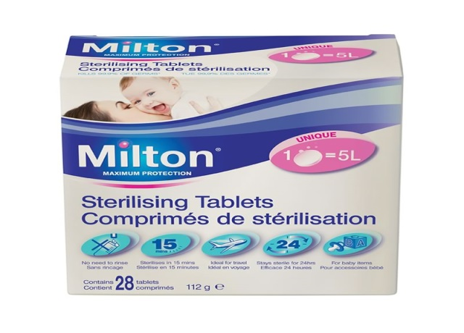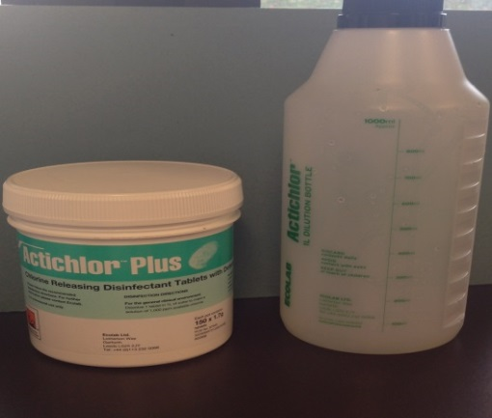

Actichlor Tablets

- An example of an effective tablet product that is effective against norovirus, flu or coronavirus is Ecolab Actichlor Tablets (follow the instructions for use to make up a 1,000ppm available chlorine). If in any doubts about product use always check with the manufacturer, especially regarding contact times. For Ecolab Actichlor tablets product needs to be in contact with surface for a minimum of 5 minutes. You can also refer to a YouTube video about the product and correct making it up:
https://www.youtube.com/watch?v=qstlXdV2Wck.

Tel: 0300 123 66 96
Email: communicabledisease@cardiff.gov.uk

