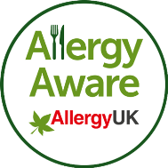

Allergy UK Allergen Awareness Training

Course Timetable
09:45 – 10.00 | REGISTRATION
10.00 – 10.10 | Welcome and Introduction
10.10 – 10.45 | The Extent of Food Allergy
10.45 – 11.10 | Allergen Information & Management
11.10 – 11.30 | TEA BREAK
11.30 – 12.05 | Dealing with Incidents
12.05 – 12.15 | The Allergy UK Allergen Awareness Scheme

